ASSIGNMENT 4:Understanding Arduino Uno R3 Pinout (With Explanation)
The Arduino Uno R3 consists of different types of pins, and each type has a specific role in connecting the board to the external world. These pins allow the Arduino to take input, process it, and give output.
Digital Pins (0–13)
- The Arduino Uno R3 has 14 digital pins. These pins work with only two values, HIGH and LOW.
- When used as input, a digital pin reads signals like whether a button is pressed or not. For example, if a button is pressed, the pin reads HIGH; otherwise, it reads LOW.
- When used as output, the pin sends signals to control components. For example, it can turn an LED ON or OFF.This makes digital pins useful for simple control tasks.
- Pins 0 and 1 have an additional function. They are used for serial communication, which helps Arduino communicate with a computer or other devices.

PWM Pins (3, 5, 6, 9, 10, 11)
- Some digital pins have PWM capability. These pins use Pulse Width Modulation to give an output that behaves like analog.
- Instead of providing a constant voltage, these pins switch ON and OFF very fast. By controlling how long the signal stays ON (duty cycle), they control the average voltage.
- Because of this, PWM pins are used when step-by-step control is needed. For example, they can control LED brightness or motor speed smoothly instead of just ON or OFF.

Analog Pins (A0–A5)
- The Arduino Uno R3 has 6 analog pins. These pins are used to read signals that change continuously.
- Sensors like temperature sensors or light sensors give output in the form of varying voltage. The Arduino cannot directly understand this, so it uses Analog-to-Digital Conversion to convert the voltage into a digital number.
- This allows the Arduino to measure real-world values and use them in decision-making.

Power Pins
- Power pins are used to supply voltage to the Arduino and connected components.
- The 5V and 3.3V pins provide power to sensors and modules. The GND pins complete the circuit by providing a common ground. The Vin pin is used when supplying power from an external source like a battery.
- Without proper use of power pins, the circuit will not function correctly.

Communication Pins
- Some pins are used for communication with other devices.
- Pins 0 and 1 are used for serial communication, which allows data exchange with a computer.
- Pins A4 and A5 are used for I2C communication, and pins 10 to 13 are used for SPI communication. These communication methods are important for connecting devices like displays, memory modules, or advanced sensors.

Reset Pin
The reset pin is used to restart the Arduino. When it is activated, the program begins execution from the start. This is useful during testing or if the system needs to be restarted.

AREF Pin
The AREF pin is used to provide a reference voltage for analog inputs. This helps improve the accuracy of analog readings, especially when working with sensors that require a specific voltage range.

Conclusion
Each pin in the Arduino Uno R3 has a clear purpose. Digital pins handle simple input and output, analog pins read real-world signals, and PWM pins provide smooth control. Power and communication pins support the overall functioning of the system. By understanding how each pin works, it becomes easier to design and implement practical electronic projects.

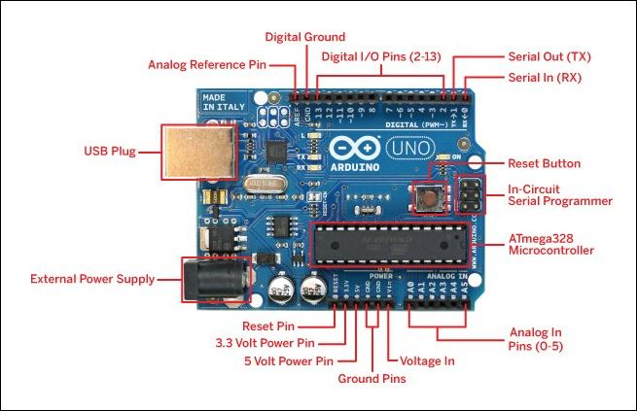
For reference:- https://www.elprocus.com/what-is-arduino-uno-r3-pin-diagram-specification-and-applications/

